**Safeguarding Staff**

Designated Safeguarding Lead: Mrs Hannah Williams



Deputy Designated Safeguarding Lead:

Mrs Aimee Mills

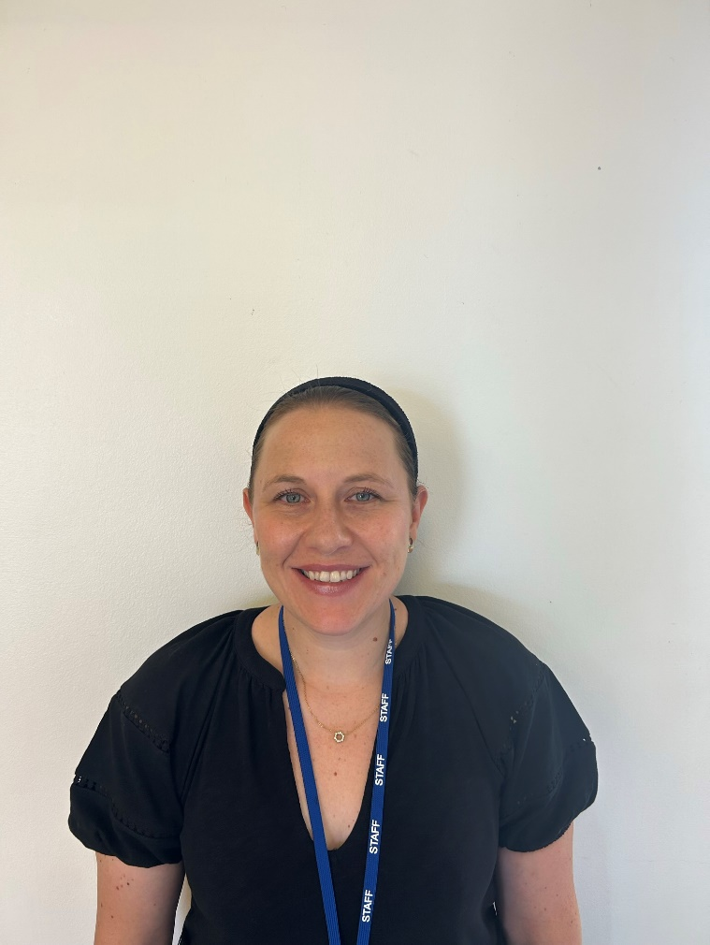

Safeguarding Governor:

Mr Jon Everitt

### Safeguarding Statement

Monkston Primary School is committed to safeguarding and promoting the welfare of children and requires all staff, volunteers and visitors to share this commitment.

This leaflet contains information about our expectations of you whilst visiting the school. If you are unclear about anything in it please speak to any of the contacts named within. Please keep the leaflet in a safe place so that you can read it again if you need to.

If you are concerned about the safety of any child in our school, you must report this to the designated safeguarding lead – Mrs Hannah Williams

If you are concerned about the conduct of a member of staff or a volunteer in our school, you must contact the Head Teacher – Mrs Hannah Williams

**Visitor Procedures**

* All visitors MUST sign in at Main Reception.
* All visitors must be issued with a visitor badge which must be displayed at all times whilst on site.
* Visitors will be asked to remain under the supervision of a designated member of staff whilst on site.
* Visitors wishing to speak to a particular member of staff should telephone the school to make an appointment, when possible, to avoid disappointment.
* Visitors must not use a smart phone or camera on site.
* Visitors MUST sign out at the Main Reception and return their visitor badge before leaving the site.



Tel: 01908 671034

## Monkston Primary School

## Monkston Primary School

# School Visitor Safeguarding Guide

Wadhurst Lane

Monkston

Milton Keynes, MK10 9LA

www.monkston.org

Monkston Primary School

* You may clarify you concern using ‘tell, explain, describe or outline’ but as soon as your concern is confirmed ask no further questions as further enquiries may be compromised.

Only trained investigators should question a child.

* Reassure the child that they have done the right thing
* Record carefully what the child says in their words including how and when the account was given. Date, time and sign the record. Pass this on to the Designated Member of Staff for Safeguarding Immediately.

**Types of Harm**

Everybody has a responsibility to keep all children under the age of 18 safe and applies to both the home and school environment. Harm is identified in four ways:

**Physical**-This is when a child is deliberately hurt or injured.

**Sexual-**this is when a child is influenced or forced to take part in sexual activity. This can be physical activity or non-physical, e.g. being made to look atinappropriate things

**Emotional**-This is when a child is made to feel frightened, worthless or unloved. It can be by shouting, using threats or making fun of someone. It can also be when children see their parents, or visitors to the home, fighting or using violence.

**Neglect**-This is when a child is not being taken care of by their parents. It can be poor hygiene, poor diet, not keeping appointments for additional support, not coming to school or being left home alone.

**Extremism and Radicalisation**-The holding of extreme political or religious views.

**Staff Conduct**

If you are concerned about the conduct of a member of staff following an observation or disclosure, the following actions must take place:

* Immediately inform the Head Teacher
* In their absence, immediately inform the Deputy Head Teacher.

**Keeping Yourself Safe**

* Be professional. Be careful how you interact with or speak to a child, the child may interpret it differently.
* Avoid physical contact with children unless you are preventing them from immediately harming themselves or others
* Avoid being on your own with a child, always ensure the door is open and that you are visible to others.
* It’s best not to do anything for a child that he/she can do for themselves
* Always tell someone if a child touches you or speaks to you inappropriately. Log down the incident time and date it and pass to the Head Teacher.
* If you have any concerns about the conduct of staff, it is your responsibility to inform the Head Teacher.

**Remember…if in doubt…ask.**

If you become concerned about:

* Something a child says.
* Marks or bruising on a student.
* Changes in a child’s behaviour or demeanour.

You must inform the Designated Safeguarding Lead.

If you feel that a child may be at risk but you are not sure, then inform the Designated Safeguarding Lead immediately who will offer advice and take appropriate action.

Child abuse happens to all children regardless of gender, culture, religion, social background and those with or without a disability.

A copy of the school’s safeguarding policy is located in the school office.

Sometimes a child may disclose information to you. If this happens then the following actions must take place.

**What do I do if a child discloses they are being harmed?**

* React calmly
* Listen carefully to the child, particularly what is said spontaneously
* Do not promise confidentiality. Explain to the child that you may need to pass on the information if you are worried about their safety.

### What do I do if I am worried about a child?